

#### MANICALAND STATE UNIVERSITY OF APPLIED SCIENCES

FACULTY OF APPLIED SCIENCES AND TECHNOLOGY

**INFORMATION SYSTEMS DEPARTMENT**

**FUNDAMENTAL OF COMPUTER ARCHITECTURE**

**CODE: BSCIS111**

### SESSIONAL EXAMINATIONS

**MAY-JUNE 2019**

**DURATION: 2 HOURS**

**EXAMINER: MR C. KURANGA**

## INSTRUCTIONS

1. *Answer* ***any four*** *questions*
2. *Each question carries 25 marks*
3. *Total marks 100*

**Question 1**

1. Compare and contrast computer 2nd generation and 3rd generation. [6]
2. Explore:
3. Architectural attribute; [3]
4. A digital computer; and [3]
5. Harvard architecture. [4]
6. Explain a computational methods layer of a digital computer. [3]
7. Discuss factors influencing computer performance. [6]

**Question 2**

1. Examine computer design, starting with the top conceptual layer and ending with the bottom layer. [15]
2. Describe a transistor-transistor logic. [10]

**Question 3**

Explain the following terms:

1. Datapath; [5]
2. Locality of reference; [4]
3. Memory access registers; [4]
4. Simple machine; [4]
5. Hardwired control unit; and [4]
6. Execution cycle. [4]

**Question 4**

1. With the aid of examples and operations, explore any **five** addressing modes. [15]
2. With the aid of a diagram, describe three-bus organization. [10]

**Question 5**

1. Write a machine language program that add the contents of memory location 12 (OOC-hex), initialized to 350 and memory location 14(00E-hex), initialized to 96, and store the result in location 16(010-hex), initialized to 0. [9]
2. Convert the following:

### (i) 342768 into Decimal Equivalent; [2]

### (ii) 26AFD16 into Decimal Equivalent; [2]

### 13510 into Binary Equivalent; [2]

### 1100102 into Decimal Equivalent; [2]

1. 2658 into Binary Equivalent; [2]

### 100112 into Octal Equivalent; [2]

### 110102 into hexadecimal Equivalent; and [2]

### 2316 into Binary Equivalent. [2]

**Question 6**

1. Using Boolean laws of algebra, simplify:
2. $X=ABC+\overline{A}B+\overline{ABC}$ [2]
3. $X=\overline{A}B\overline{C}+A\overline{B}\overline{C}+\overline{A}\overline{B}\overline{C}+\overline{A}\overline{B}\overline{C}$ [3]
4. Prove the following Boolean algebraic expressions:
5. $AB+\overline{A}C+BC=AB+\overline{A}C$ [3]
6. $\left(A+B\right)\left(\overline{A}+C\right)\left(B+C\right)=(A+B)\left(\overline{A}+C\right)$ [4]
7. Write the Boolean expression that describes mathematically the behavior of logic circuit shown in below. Use a truth table to determine what input conditions produce a logic 1 output. [7]

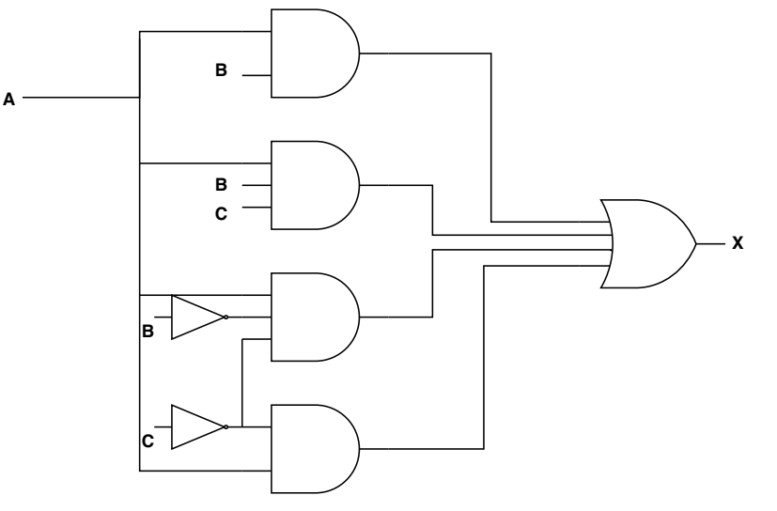

1. Given the Boolean expression:
$$X=AB+ABC+A\overline{B}\overline{C}+\overline{A}C$$

2. Draw the logic diagram for the expression. [3]
3. Minimize the expression. [3]

**END OF EXAMINATION**