FACULTY OF SCIENCE & TECHNOLOGY

MIDLANDS STATE UNIVERSITY

Chemical and Processing Engineering Department
PHYSICAL CHEMISTRY
CODE: HCHE 112

SESSIONAL EXAMINATIONS
DECEMBER 2016
DURATION: 3 HOURS
EXAMINER: Dr I NYAMBIYA

INSTRUCTIONS
- Answer ALL questions
- Each question carries 25 marks
- Total marks 100

Additional material
Calculator allowed
Graph Paper

QUESTION 1
- Why is Chemistry sometimes called a central science? [2 marks]
- State five of the practices and principles of physics that physical chemistry employs. [5 marks]
- Give the symbol and base units of the following physical quantities:
- Length
- Mass
- Time
- Electric current
- Thermodynamic temperature
- Luminous intensity [7 marks]
- How do you describe an electronvolt? [1 mark]
- Write down the general form of an equation of state [1 mark]
- What is the difference between intensive and extensive properties? Give examples. [3 marks]
- Why is Dalton’s Law a limiting law? [1 marks]
- Calculate the molar volume of a perfect gas at standard ambient temperature and pressure (SATP), which means 298.15 K and 1 bar and standard temperature and pressure (STP) which is 0°C and 1 atm. Comment on these two values. [5 marks]

QUESTION 2
- Define the following terms as used in thermodynamics
- open system
- closed system
- isolated system
- surroundings
- heat
- work [7 marks]
- What is the internal energy U and the enthalpy H of a system?
Write down an expression for the First Law of Thermodynamics
which relates the change in internal energy of a system to the
work done on the system and the heat absorbed by the system.
Hence derive a relationship between the change in internal
energy ∆U and the change in enthalpy ∆H of a system.
[10 marks]
- If an electric motor produced 15 kJ of energy each second as mechanical work and lost 2 kJ as heat to the surroundings what is the change in the internal energy.
Suppose that, when a spring was wound, 100 J of work was done on it but 15 J escaped to the surroundings as heat. Also give the change in U. [2 marks]
- Consider the isothermal, reversible expansion of a perfect gas as represented in Figure 1.

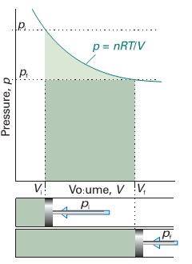
Figure 1
Derive an expression for the work of expansion of the gas from Vi to Vf. [6 marks]

QUESTION 3
- Briefly define the following terms as used in quantum chemistry
- duality
(ii) photons
(iii) work function
(iv) de Broglie relationship
(v) electron diffraction [5 marks]
- Describe the following diagrams (Fig. 2) as sufficiently as possible in terms of your knowledge of quantum chemistry. [5 marks]
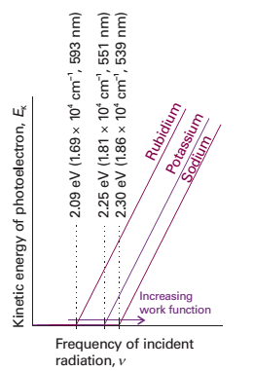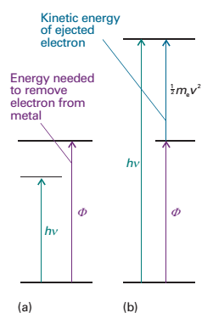Figure 2

- Calculate:
- the wavelength of a neutron with a translational kinetic energy equal to kT at 300 K,
- a tennis ball of mass 57 g travelling at 80 km/h [5 marks]
- Photoelectric experiments show that about 5 eV of energy are required to remove an electron from platinum.
i. What is the maximum wavelength of light that will remove an electron?
ii. If light of 150 nm wavelength were used, what is the velocity of the emitted electron? [10 marks]

QUESTION 4
(a) Describe briefly the following methods for determining the rate laws of chemicals reactions:
(i) isolation method (ii) differential method (iii) integral method
(iv) absorption spectrometry (v) flow techniques [5 marks]
(b) The variation in the partial pressure of azomethane with time was followed at 600 K, with the results given in Table 1. Confirm that the decomposition
is first-order in azomethane, and find the rate constant at 600 K. [10 marks]
Table 1
Time (s) | 0 | 1000 | 2000 | 3000 | 4000
Pressure (Pa) | 10.9 | 7.63 | 5.32 | 3.71 | 2.59
- The kinetics of many enzyme reactions may be described in terms of the Michaelis-Menten mechanism. If S represents the substrate molecule and E is the enzyme then a simple form of the Michaelis-Menten mechanism is
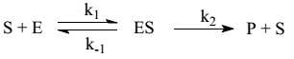
where ES represents the enzyme/substrate complex. The reaction rate R is given by R = k₂[ES ]
Use the steady state approximation to evaluate the enzyme/substrate
complex concentration [ES] and hence show that the rate of product formation R is given by $R=\frac{k_{c}\left[S\right][{E]}_{⅀}}{K_{M}+[S]}$ where k_{c} = k₂ is the catalytic rate constant and $K_{M}=\frac{k_{-1}+k_{2}}{k_{1}}$ is the Michaelis constant. Note that the total enzyme concentration is given by $[{E]}_{⅀}=\left[E\right]+\left[ES\right]$where [E] represents the concentration of free enzyme. Provide an interpretation of K_{M} and k_{c}.
[10 marks]
PERIODIC TABLE
