FACULTY OF SCIENCE & TECHNOLOGY

MIDLANDS STATE UNIVERSITY

Chemical and Processing Engineering Department
CORROSION CHEMISTRY
CODE: HCHE 124

SESSIONAL EXAMINATIONS
DEC 2016

DURATION: 3 HOURS

EXAMINER: Dr MAMBO MOYO

INSTRUCTIONS
Answer question ONE and any three other questions
Each question carries 25 marks
Total marks 100

QUESTION 1
(a) Read an abstract by Gonzalez-Rodriguez et al., (2016) and answer the questions that follow:
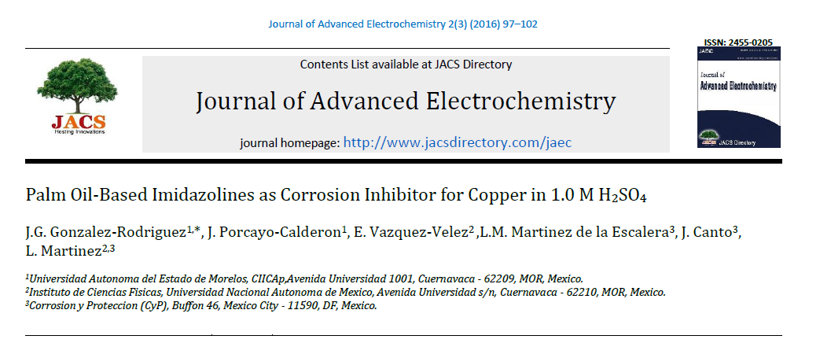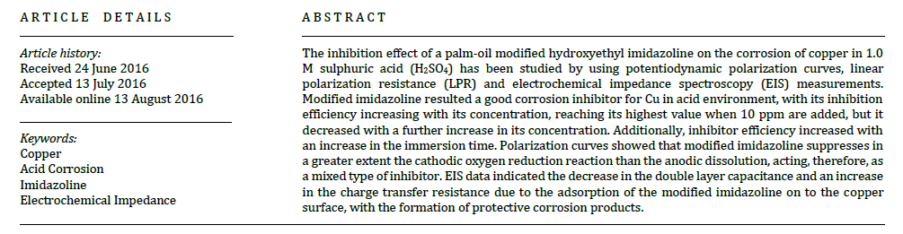
(i) What are corrosion inhibitors and give an example from the abstract? [2 marks]
(ii) State the electrolyte in which the process of corrosion inhibition was studied. [1 mark]
(iii) Give the techniques that were used to study the inhibition effect? [2 marks]
(iv) What was the effect of using modified imidazoline? [1 mark]
(b) Define the following terms:
(i) Specific volume ratio,
(ii) Polarization. [2 marks]
(c) Describe briefly water line corrosion. [4 marks]
(d) Draw and label a diagram to describe each of the following:
(i) The use of a polarization curve to calculate a cathodic Tafel constant.
(ii) An anodic polarization curve exhibiting passivation. [6 marks]
(e) Lead experiences corrosion in an acid solution according to the reaction:
The rates of both oxidation and reduction half-reactions are controlled by activation polarization.
(i) Compute the rate of oxidation of Pb (in mol/cm² s⁻¹) given the following activation polarization data: [4 marks]
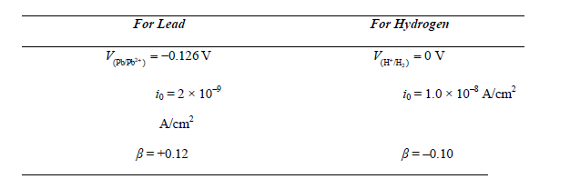
(ii) Compute the value of the corrosion potential. [3 marks]

QUESTION 2
(a) Describe the recipe for corrosion. [4 marks]
(b) Describe any four consequences of corrosion in a chemical and process engineering company. [8 marks]
(c) A thick steel sheet had a rate of corrosion of 2.5 mm/yr obtained after exposed to air near the ocean. After a one-year period it was found to experience a weight loss of 880 g due to corrosion. To what area, in cm², does this correspond? [3 marks]
(d) What is involved in liquid–metal corrosion? [3 marks]
(e) Describe the differences between chemical and electrochemical corrosion. [6 marks]
(f) Define the EMF series. [1 mark]
QUESTION 3
(a) Explain clearly the meaning of the following terms when used in the context of E/pH diagrams: immunity; corrosion; passivation. [3 marks]
(b) Give two useful functions of E/pH diagrams. [5 marks]
(c) Give two limitations to their use [2 marks]
(d) What is involved in proper designing during corrosion control? [4 marks]
(e) State three types of protective coating mainly encountered in chemical and process engineering plants. [3 marks]
(f) Briefly explain why cold-worked metals are more susceptible to corrosion than noncold-worked metals. [2 marks]
(g) Cite the major differences between activation and concentration polarizations. [2 marks]
(h) A piece of corroded steel plate was found in a submerged ocean vessel. It was estimated that the original area of the plate was 62.5 cm² and that approximately 2.8 kg had corroded during the submersion. Estimate the time of submersion in years given that the corrosion penetration rate is 5.1 mm/yr for this alloy in seawater. The density of steel is 7.9 g/cm³. [4 marks]
QUESTION 4
(a) Describe stress cracking corrosion under the following headings:
(i) Principles
(ii) Prevention methods. [4 marks; 2 marks]
(b) Demonstrate that CPR is related to the corrosion current density i (A/cm²) through the expression:
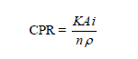
where K is a constant, A is the atomic weight of the metal experiencing corrosion, n is the number of electrons associated with the ionization of each metal atom, and ρ is the density of the metal. [6 marks]
(c) With the aid of diagrams, briefly describe the two techniques that are used for galvanic protection. [5 marks]
(d) Comment on the calculated results shown in the Table 1. [2 marks]
Table 1: Al corrosion rate
% Purity of Al | 99.99 | 99.97 | 99.20
Relative rate of corrosion | 1 | 1000 | 30000
(e) Identify the following types of corrosion:
(i) (ii)
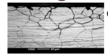
(iii)
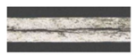 [3 marks]
(f) Write short notes on Soil Corrosion. [3 marks]
QUESTION 5
(a) (i) Explain what is meant by the term 'passivity' in the context of corrosion.
(ii) Give two examples of natural passivity of metals. [1 mark; 2 marks]
(b) Mention the theories of corrosion [3 marks]
(c) Imagine that you are asked to investigate the rate of corrosion of an Inconel 625 reactor in the particular environment of a chemical process.
(i) Describe the basic equipment you would need to carry out a laboratory investigation. [4 marks]
(ii) Explain the role of each piece of equipment mentioned in (i). [3 marks]
(iii) Describe one experiment which you would perform, clearly stating the conditions for the experiment. [4 marks]
(iv) Explain how you would interpret data obtained from your experiment. [3 marks]
(v) List the other parameters which might usefully be varied and explain how further information relating to the corrosion performance in the reactor might be obtained as a result. [3 marks]
(vi) Discuss the limitations of the experiment you have described in the context of other forms of corrosion to which the material may be susceptible. [2 marks]
END OF QUESTION PAPER

