FACULTY OF SCIENCE & TECHNOLOGY

MIDLANDS STATE UNIVERSITY

Mining and Mineral Processing Engineering Department

ENGINEERING DRAWING
CODE: HMIE 111

SESSIONAL EXAMINATIONS

DECEMBER 2016

DURATION: 4 HOURS

Examiner: Mr. C. Chewu

INSTRUCTIONS
- This paper consists of 5 questions

- Answer all questions

- Requirements: -A3 sheets

-Drawing instruments

-Scientific calculator

QUESTION 1

Draw, with the help of drawing instruments, the following component shown in Fig. 1 below [20]

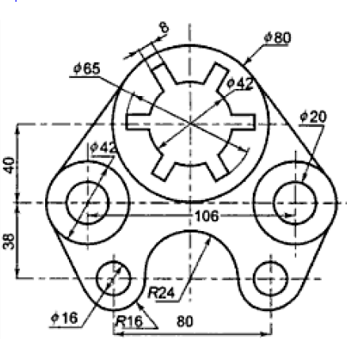

Fig. 1

QUESTION 2

A Cam of radius 50 mm turning uniformly clockwise is to give a lift of 30 mm to a follower which moves on a vertical straight line 20 mm to the right of centre of Cam shaft, the follower being above the Cam. The follower is fitted with a roller of 25 mm diameter and is to have the following motion:

0 – 180ᵒ: Rising with harmonic motion
180-270ᵒ: Falling 15 mm with uniform acceleration
270 – 360ᵒ: Falling 15 mm with uniform deceleration
Draw the Cam profile to full size using intervals of 30ᵒ and the follower path. [20]

QUESTION 3

The diagram in Fig. 2 below shows a crank. Looking in the direction of the arrow X, draw the front view, top view and left side view of the crank in first angle projection. [15]
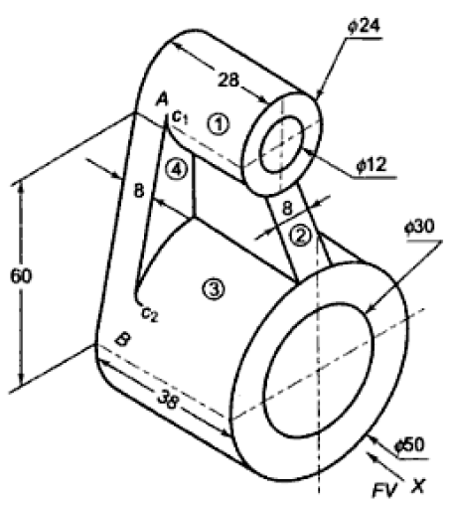
Fig. 2

QUESTION 4

Draw, in first angle projection, the arrangement of a Nut and Washer on an M 24 x 3 6 g whose length = 90 and thread length = 60.
[20]

QUESTION 5

The drawing in Fig. 3 shows: i) a pictorial sketch of a lathe- gear change lever to act as a guide showing you how its parts are fitted together, ii) details of the various parts of the gear change lever.
You are required to do the following:
- Draw the front view by adding the parts to make the whole assembly
- Draw the sectional plan on A-A
- Draw the end view

Do not show any hidden details
Dimension the following:
- The diameter of the knob of the lever handle
- Total length of the lever handle
- The two 8mm holes
Use your own judgment to determine the size of any dimension not given.
Make sure that the views are correctly positioned and in correct projection before drawing in any detail.
Credit will be given for good draughtsman-ship and layout as well as for correct answers. [25]

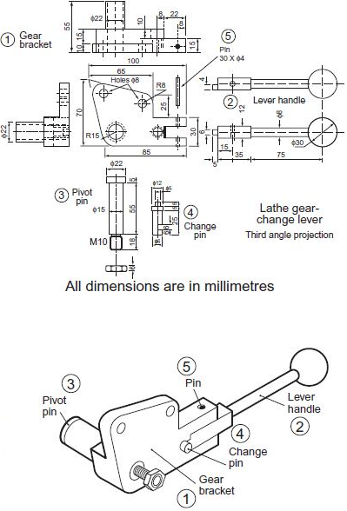

Fig.3

END OF PAPER

