FACULTY OF SCIENCE & TECHNOLOGY

MIDLANDS STATE UNIVERSITY

Mining and Mineral Processing Engineering Department

MECHANICAL ENGINEERING DESIGN
CODE: HMIE 217

SESSIONAL EXAMINATIONS
DECEMBER 2016
DURATION: 3 HOURS
Examiner: Mr. C. Chewu

INSTRUCTIONS

- This paper consists of 6 questions

- Answer any four questions

- Requirements:
-Scientific calculator

QUESTION 1

- With aid of a clearly labeled diagram, explain the Engineering design cycle, giving practical examples where relevant. [10]
- Discuss the effect of the following alloying elements on steel:
- Nickel
- Chromium
- Tungsten [6]
- Discuss the applications of the following material with reference to their mechanical properties:
- Cast iron
- Aluminum
- Plain carbon steel
- Ceramics
- Timber [9]

QUESTION 2

A gear drive is required to transmit a maximum power of 22.5 kW. The velocity ratio is 1:2 and r.p.m. of the pinion is 200. The approximate centre distance between the shafts may be taken as 600 mm. The teeth have 20° stub involute profiles. The static stress for the gear material (which is cast iron) may be taken as 60 MPa and face width as 10 times the module. Find the module, face width and number of teeth on each gear.
Check the design for dynamic and wear loads. The deformation or dynamic factor in the Buckingham equation may be taken as 80 and the material combination factor for the wear as 1.4. [25]
QUESTION 3

- Design an open flat belt drive to transmit 110 kW for a system consisting of two pulleys of diameters 0.9 m and 1.2 m, centre distance of 3.6 m, a belt speed 20 m / s, coefficient of friction 0.3, a slip of 1.2% at each pulley and 5% friction loss at each shaft, 20% over load. Assume a density of 1000 kg/m³ for the belt material, a thickness of 0.015 m and an allowable stress of 2.5 MN/m². [18]
- Explain why the slack side of an open belt drive is preferable to place on the top side. [2]
- Describe any five advantages of flat belt drives over the other type of drives. [5]

QUESTION 4

- Using the Maximum Principal Stress theory and the Maximum Shear Stress theory, derive the equations for determining the maximum normal stress (σ₁) and maximum shear stress (τ_{max}) for a solid circular shaft subjected to combined bending and torsion. [7]
- The shaft of the crank lever is loaded by forces through a vertical pin plate as shown in Fig. 1. The pin is subjected to a vertical force of 8 kN at C. An axial thrust of 5 kN is acting at D on the base plate which may be approximated as equivalent axial force acting on the shaft AB supported at point A. The yield stress for the shaft material is taken as 300 MN/m² and the factor of safety is taken as 3. Calculate diameter of the shaft AB. Use shock and fatigue factor in bending and torsion as 2.0 and 1.5 respectively. Assume slenderness ratio to be equal to 30. [18]
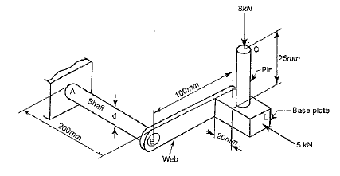
Fig. 1

QUESTION 5

- State what the following theories outline in predicting the failure stresses for members subjected to static loading, include equations:
- Maximum principal stress theory
- Maximum principal strain theory
- Maximum shear stress theory
- Maximum distortion energy theory [8]
- A hand cracking lever, shown in Fig. 2 is used to start a truck engine by applying a force F=400 N. The material of the cranking lever is 30C8 for which Yield strength = 320 MPa, Ultimate tensile strength = 500 MPa, Young modulus = 205 GPa, Modulus of rigidity = 84 GPa and Poisson’s ratio = 0.3. Assuming a factor of safety of 4 to be based on yield strength, determine, the diameter‘d’ of the lever at the section X-X near the guide bush using:
- Maximum distortion energy theory
- Maximum shear stress theory
[17]
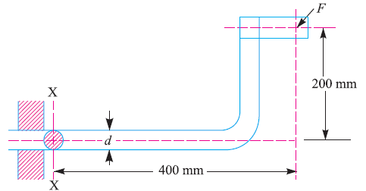
Fig. 2
Question 6

- Define the following terms as they are used in prediction of failure due to variable loading:
- Fluctuating stresses
- Completely reversed stresses
- Endurance limit
- Stress concentration
- Notch sensitivity [5]
- State and describe any 2 processes used in reducing fatigue failure in machine components. [6]
- A component machined from a steel C45 (ultimate tensile strength of 630 MPa) is shown in Fig. 3. It is subjected to a reversed axial force of 50 kN. The expected reliability is 90% (reliability factor of 0.89) and the factor of safety is 2. Using the Goodman’s method, determine the plate thickness for infinite life. Notch sensitivity can be taken to be 0.8 and theoretical stress concentration factor, K_{t}, can be taken as 2.275. [14]

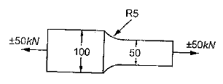
Fig. 3

Important formulae and Data:
Variable loading
- Gerber relation:
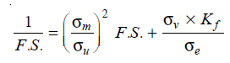
- Goodman relation (for bending load):
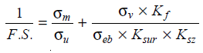
- Soderberg relation (for bending load):
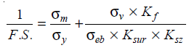
Shafting
- Combined bending, torsion and axial stress:
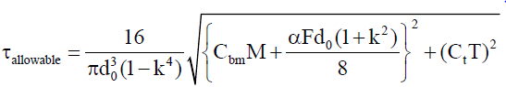
- Column factor:
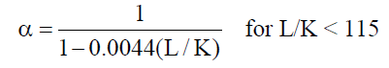
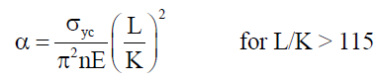
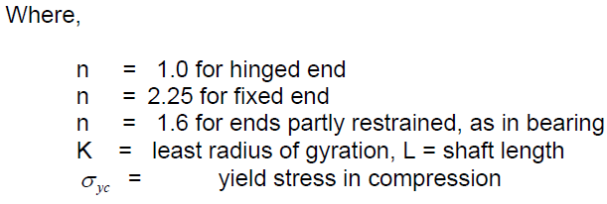

- Table for bending and torsion factors:
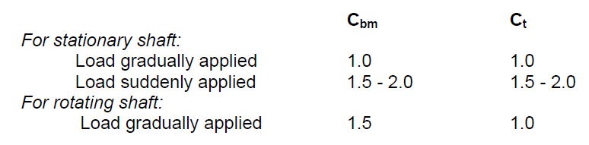

Flat Belts
- Length of an open flat belt:
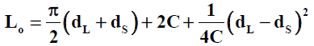

- Length of a cross belt drive:
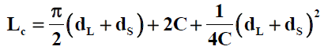

END OF EXAM

