FACULTY OF SCIENCE & TECHNOLOGY

MIDLANDS STATE UNIVERSITY

Mining and Mineral Processing Engineering Department

PRINCIPLES OF ELECTRICAL ENGINEERING
CODE: HMIE 221

SESSIONAL EXAMINATIONS

DECEMBER 2016

DURATION: 3 HOURS
EXAMINER: MR E CHIPFUPI

INSTRUCTIONS

- Answer All Questions
- All questions carry equal marks
- Total marks:100

QUESTION 1

- Define the following terms
- Root mean square current
- Root mean square voltage
- Impedance
- Reactance
- Resonant frequency [5]

- For the RLC circuit shown in Figure 1, show that
$Q_{0}=\frac{V_{0}}{ω\sqrt{R^{2}+(X_{L}-X_{C})^{2}}}$ [10]
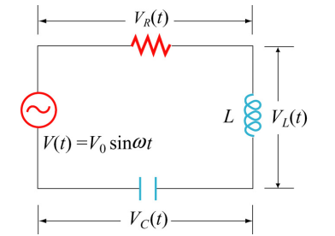
Figure 1

      - An instrumentation amplifier shown in Figure 2 is an amplifier of low-
level signals used in process control or measurement applications and
commercially available in single-package units. Show that
$v_{0}=\frac{R_{2}}{R_{1}}\left(1+\frac{{2R}_{3}}{R_{4}}\right)\left(v_{2}-v_{1}\right)$ [10]
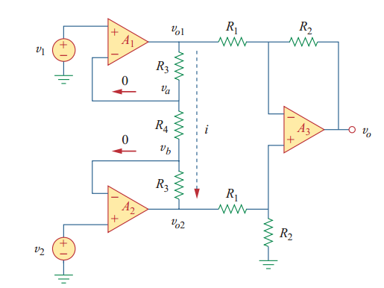
Figure 2

QUESTION 2

- Calculate the average power absorbed by each of the five elements in the circuit of Figure 3. [10]
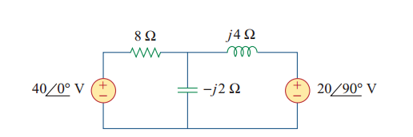
Figure 3
- Obtain the line currents in the three-phase circuit of the circuit shown in Figure 4. [10]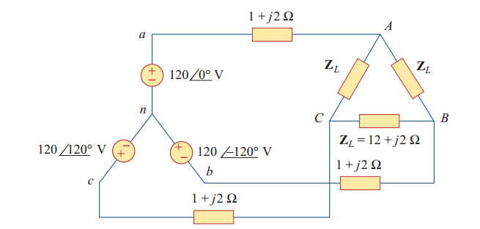
Figure 4

- Assume $I_{0}=1A$ and use linearity to find the actual value of $I_{0}$in the
circuit of Figure 5. [5]
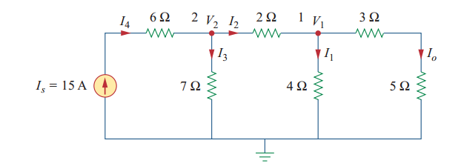
Figure 5

QUESTION 3

- A 50 hp, 250 V, 1200 rpm DC shunt motor with compensating windings has
an armature resistance (including the brushes, compensating windings, and
interpoles) of 0.06 Ω. Its field circuit has a total resistance R_{adj} + R_{F} of 50 Ω, which produces a no-load speed of 1200 rpm. The shunt field winding has 1200 turns per pole.
(i) Find the motor speed when its input current is 100 A. [5]
(ii) Find the motor speed when its input current is 200 A. [5]
(iii) Find the motor speed when its input current is 300 A. [5]
(iv) Plot the motor torque-speed characteristic. [5]

- What are the Advantages of three-phase systems over single-phase supplies?
[5]

QUESTION 4

- A 5 kVA single-phase transformer has a turns ratio of 10:1 and is fed from a 2.5 kV supply. Neglecting losses, determine
- the full-load secondary current,
- the minimum load resistance which can be connected across the secondary winding to give full load kVA,
- the primary current at full load kVA.
[10]
- A 50-kVA 13800/208V ∆-Y distribution transformer has a resistance of 1% and a reactance of 7% per unit.
  - What is the transformer’s phase impedance referred to the high voltage side? [4]
ii. Calculate this transformer’s voltage regulation at full load and 0.8pf lagging, using the calculated high side impedance. [5]
iii. Calculate this transformer’s voltage regulation under the same conditions, using the per-unit system [6]
END OF PAPER

