FACULTY OF SCIENCE & TECHNOLOGY

MIDLANDS STATE UNIVERSITY

Chemical and Processing Engineering Department

STRENGTH OF MATERIALS
CODE: HCHE 226

SESSIONAL EXAMINATIONS
DECEMBER 2016
DURATION: 3 HOURS
Examiner: Miss K. Chiwanga

INSTRUCTIONS
- The paper consist of six Questions
- Answer any five questions
- Total marks 100
Additional Material: Graph Paper

Question 1
The data shown in Table 1 was recorded during a tensile test of a 14 mm diameter mild-steel rod. The gauge length was 50.0 mm.
Table 1: Tensile strength data
LOAD (N) | ELONGATION (mm)
0 | 0
6 310 | 0.010
12 600 | 0.020
18 800 | 0.030
25 100 | 0.040
31 300 | 0.050
37 900 | 0.060
40 100 | 0.163
41 600 | 0.433
46 200 | 1.25
52 400 | 2.50
58 500 | 4.50
68 000 | 7.50
69 000 | 12.5
67 800 | 15.5
65 000 | 20.0
61 500 | Fracture

- Plot the stress-strain diagram using data in Table 1. [15]
- Using the graph plotted in question 1 a, explain and determine the following mechanical properties:
- Proportional limit
- Modulus of elasticity
- Yield strength
- Ultimate strength
- Rupture strength [5]

Question 2
- A circular steel tube of length L = 1.0 m is loaded in torsion by torques T (Figure 1).
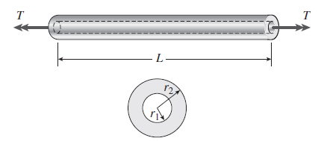
Figure 1
- If the inner radius of the tube (r₁) is = 45 mm and the measured angle of twist between the ends is 0.5°, what is the shear strain (in radians) at the inner surface?
- If the maximum allowable shear strain is 0.0004 rad and the angle of twist is to be kept at 0.45° by adjusting the torque T, what is the maximum permissible outer radius (r₂)? [10]
- A shaft is transmitting 97.5 kW at 180 r.p.m. If the allowable shear stress in the material is 60 MPa, find the suitable diameter for the shaft. The shaft is not to twist more than 1° in a length of 3 meters. Assume C = 80 GPa. [5]
- A solid steel shaft has to transmit 75 kW at 200 r.p.m. Taking allowable shear stress as 70 N/mm², find suitable diameter for the shaft, if the maximum torque transmitted at each revolution exceeds the mean by 30%. [5]

Question 3
- The following beam of length 6 m carries the point loads as shown in Figure 2, draw the S.F.D and B.M.D for the beam. [8]
30N
60N
2m
2m
2m

Figure 2: Supported Beam
- What is the point of contraflexure and its importance to a design engineer? [4]
- A simply supported beam (Figure 3) of length 7 m carries a uniformly distributed load of 5kN/m, and two points of load 40 kN and 10 kN. Draw the S.F.D and B.M.D diagrams for the beam. [8]
U₁=5kN/m
10kN
40kN

3m
2m
2m

Figure 3: Supported beam

Question 4
- An axial pull of 35000 N is acting on a bar consisting of three lengths as shown in Figure 4 if the young’s modulus = 2.1 x 10⁵ N/mm² determine:
- Stresses in each section. [3]
- Total extension of the bar. [3]
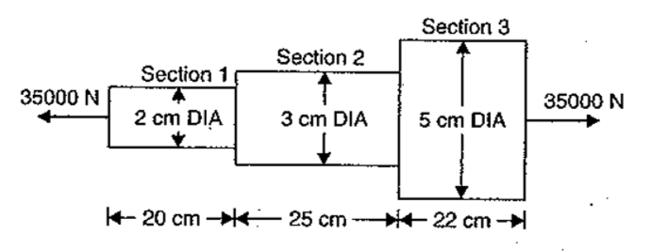
Figure 4: Axial pull
- Three bars made of copper, zinc and aluminium (Figure 5) are of equal length and have cross-section 500, 750 and 1000 mm² respectively. They are rigidly connected at their ends. If this compound member is subjected to a longitudinal pull of 250 kN, estimate the proportional of the load carried on each rod and the induced stresses. Assume the value of E for copper = 1.3 x 10⁵ N/mm², zinc = 1.0 x 10⁵ N/mm² and aluminium= 0.8 x 10⁵ N/mm². [6]

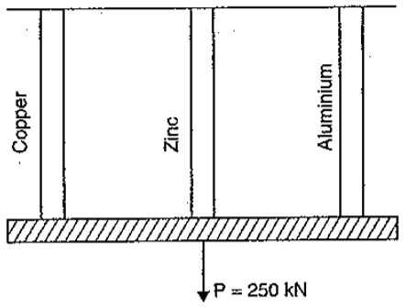
Figure 5: Three metal bars

- State any eight points of your choice which a design engineer should consider before selecting a proper factor of safety. [8]

Question 5
- Explain the following terms :
- Creep
- Laminated spring
- Helical compression and extension spring
- Torsion spring
- Elasticity [10]
- Derive expression for the volumetric strain of a thin cylinder. [5]
- A thin cylinder of internal diameter 1.25 m contains a fluid at an internal pressure of 2 N/mm². Determine the maximum thickness of the cylinder if :
- The longitudinal stress is not to exceed 30 N/mm². [2]
- The circumferential stress is not to exceed 45 N/mm². [3]

Question 6
- A closely coiled helical spring made of 10 mm diameter steel wire has 15 coils of 100 mm mean diameter. The spring is subjected to an axial load of load of 100 N. Calculate:
- The maximum shear stress induced,
- The deflection,
- Stiffness of the spring.
Take modulus of rigidity, C = 8.16 x 10⁴ N/mm². [6]
- Explain the following terms:
- Isotropy [2]
- Anisotropy [2]
- Bending strength [2]
- Torsional strength [2]
- Resilience [2]
- Determine the value of Young’s modulus and poisson’s ratio of a metalic bar of length 30 cm, breadth 4 cm and depth 4 cm when the bar is subjected to an axial compressive load of 400 kN. The decrease in length is given as 0.075 cm and increase in breadth is 0.03 cm. [4]
END OF PAPER

