**;**

#### MANICALAND STATE UNIVERSITY OF APPLIED SCIENCES

**FACULTY OF ENGINEERING, APPLIED SCIENCES AND TECHNOLOGY**

**DEPARTMENT: MINING AND MINERAL PROCESSING ENGINEERING**

**MODULE: WORKSHOP PRACTICE**

**CODE: CHEP123/ CHEP126**

**SESSIONAL EXAMINATIONS**

**DECEMBER 2023**

**DURATION: 2 HOURS**

**EXAMINER: D. DHLIWAYO**

## INSTRUCTIONS

1. *This paper consists of 6 questions*
2. *Answer QUESTION* ***1*** *and any other* ***four*** *questions.*
3. *Start a new question on a fresh page*
4. *Total marks 100*

**QUESTION 1** (*2-mark short answer questions*)

1. What are the uses of a centre punch and callipers?
2. Name any 3 types of hammers.
3. Name any 3 types of files.
4. Name any 2 parts of a Lathe and their uses.
5. Name any 3 tempering baths.
6. What is facing and parting?
7. Explain the need of chamfering bolts and nuts.
8. Which welding technique is used to join stainless steel and aluminium?
9. State any 2 purposes for heat treating metals?
10. What are the uses of the flashback arrestor and the mixing chamber in oxy –

acetylene gas welding?

**QUESTION 2**

1. Describe the uses of the following machines:
2. Lathe
3. Milling
4. Radial Drilling
5. Bending and rolling [12]
6. Briefly explain the uses & operations of Computer Numerical Machines. [8]

**QUESTION 3**

1. Using relevant diagrams, describe Resistance Spot Welding (RSW) and state any 3 advantages of RSW over other types of welding. [10]
2. Explain fully, using suitable diagrams, the process of Electric Arc Welding.

[10]

**QUESTION 4**

1. Describe fully the following heat treatment methods:
2. Annealing
3. Normalising
4. Hardening
5. Tempering [20]

**QUESTION 5**

1. Describe the uses of the following workshop holding tools. [9]
2. Bench vice
3. V-Block
4. C-Clamp

b) Identify any 3 marking tools for the bench fitting shop and state the use of each tool. [3]

1. Describe briefly the following bench shop processes:
2. Filing
3. Chipping
4. Sawing
5. Grinding [8]

**QUESTION 6**

1. A cylindrical stainless-steel rod with length L=150 mm, diameter 12 mm is being reduced in diameter to 11 mm by turning on a lathe. The spindle rotates at N = 400 rpm, and the tool is travelling at an axial speed of υ=200 m/min

Calculate:

i) The cutting speed V (maximum and minimum) [3]

ii) The material removal rate, MRR [3]

iii) The cutting time, t [2]

iv) The power required if the unit power is estimated to 4 W.s/mm3 [2]

1. The part shown in Figure 1 will be turned in two machining steps. In the first step a length of (50 + 50) = 100 mm will be reduced from Ø100 mm to Ø80 mm and in the second step a length of 50 mm will be reduced from Ø80 mm to Ø60 mm. Calculate the required total machining time T, with the following cutting conditions:

-Cutting speed V=80 m/min,

-Feed is f=0.8 mm/rev,

-Depth of cut = 3 mm per pass. [10]

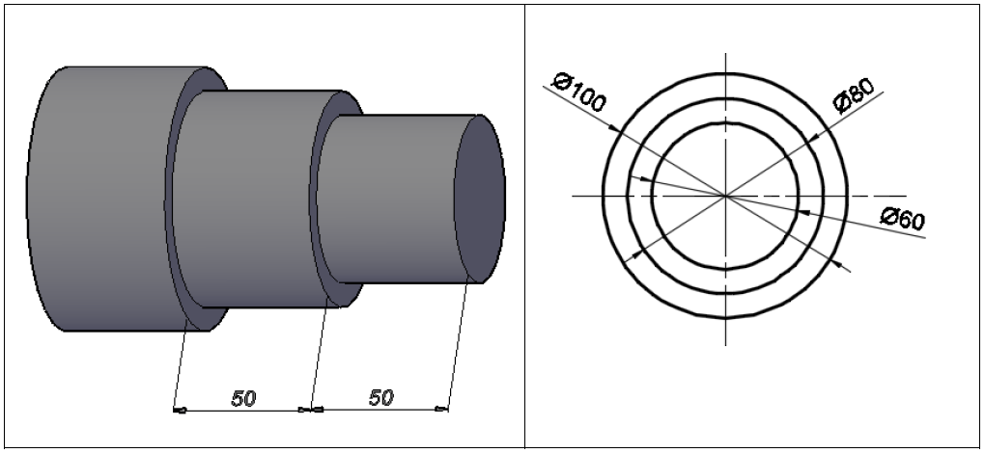

Figure 1

**END OF EXAMINATION**