;

#### MANICALAND STATE UNIVERSITY OF APPLIED SCIENCES

FACULTY OF ENGINEERING, APPLIED SCIENCES AND TECHNOLOGY

**DEPARTMENT: MINING AND MINERAL PROCESSING ENGINEERING**

**MODULE: MECHANICAL METALLURGY**

**CODE: HMME 324**

### SESSIONAL EXAMINATIONS

**DECEMBER 2023**

**DURATION: 3 HOURS**

**EXAMINER: MS P. R. NYONI**

## INSTRUCTIONS

1. *Answer* ***All*** *questions*
2. *Where applicable, show all working*
3. *Materials data sheet is provided at the end of the paper.*
4. *A scientific non-programmable calculator is allowed.*

**QUESTION 1**

1. The bar in Figure 1 below is made of hot rolled 1020 steel, has the dimensions in the Figure 1 below,



*Figure 1 showing the bar made of hot rolled 1020 steel.*

1. Determine whether the bar deforms elastically or plastically. [3]
2. Calculate the length of the bar under the applied load. [5]
3. What is the cross-sectional area of the bar under the applied load? [2]
4. An acrylic rod is 200mm long and 15 mm in diameter. If an axial load of 300N is applied to it, determine;
5. The axial strain; [4]
6. The percent change in diameter [3]

Take E = 2.70 GPa and υ= 0.4

1. A beam similar to that shown in the image in figure 2 was made of AISI 1050 with σyield = 335 MPa σuts = 626 MPa. The stresses near the weld are presented in the adjacent stress element.



*Figure 2 showing a beam made of AISI 1050.*

1. Determine the principal stresses and maximum shear stress. [5]
2. Use the Von Mises criterion to show that the beam will fail by yielding near the weld. [4]

**[Total 26]**

**Question 2**

1. The Table 2 below shows partial results obtained when metal X with an FCC crystal structure, a cross sectional area of 78mm2 and length of 30.8mm was subjected to a tensile test.

*Table 1 showing partial results obtained.*

|  |  |
| --- | --- |
| True stress (MPa) | True strain |
| 24.98 | 0.132 |
| 34.43 | 0.297 |
| 46.91 | 0.674 |

1. Determine the strain hardening coefficient of metal X. [4]
2. Determine the length of the specimen at necking. [3]
3. Explain why metal X cannot be aluminium. [2]
4. Examine the fracture surface in the figure 3;



*Figure 3 showing the fracture surface.*

1. Name the type of fracture. Explain your answer. [2]
2. Describe how such a fracture is formed. [4]
3. What stress state caused the fracture in the figure? Justify your answer. [6]
4. Mention and discuss one human cause and one physical cause that could have contributed to the failure of the tube. [4]

**[Total 25]**

**Question 3**

a) The hollow bar in Figure 4a was subjected to an axial load of 369kN. The bar is made of an alloy having the stress-strain curve in Figure 4b.

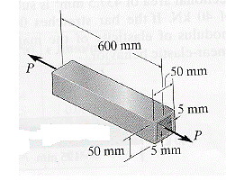

Figure 4a Figure 4b

1. Determine whether the bar deformed plastically or elastically under this load. Explain. [3]
2. Determine the length of the bar under this load. [4]
3. What is the resilience of the alloy. [3]
4. Suggest how the value in (iii) may be increased. Explain. [2]
5. The fracture toughness for 7178 aluminium (Al-Cu-Mg) is 33 MPa $√m$. A plate made of this alloy has an edge crack that is 12.8mm long. The plate is 75mm wide and 6 mm thick.
6. Will the crack propagate under a static load of 300MPa? Explain. [4]
7. Suggest how the fracture toughness of the plate may be improved. [2]
8. Determine the rate of crack propagation if the plate is subjected to a completely reversed stress of 300MPa. [5]

Assume C = 2.71 x 10-8 MPa for mm/cycle; m =3.70

1. Why are cracks more detrimental for brittle materials than ductile materials?

[2]

**[Total 25]**

**Question 4**

1. A ductile cast iron with a diameter of 40 mm is operated in a furnace used to fire ceramic bricks. The rod was designed for use for 5 years at 600°C under an axial load of 23 kN. However, during operation, the rod is accidentally exposed to a temperature of 627°C.

Determine how long the rod would last. Take C = 23 [3]

1. A 50mm long rod with a diameter of 10mm and of unknown chemical composition was subject to a tensile test till fracture. The results obtained are presented in figure 5 below:

*Figure 5 showing tensile properties of the rod.*

1. Determine the ultimate tensile stress of the metal. [7]
2. Calculate the length of the rod at necking. [3]
3. Describe two microscopic features of the fracture surface. Explain your answers. [4]
4. Suggest a suitable technique for examining the fracture. [2]
5. The stresses at a point in a bar Figure 6(a) are shown in Figure 6(b). if the material is aluminium for which, E= 70GPa, υ =0.3

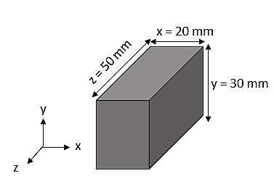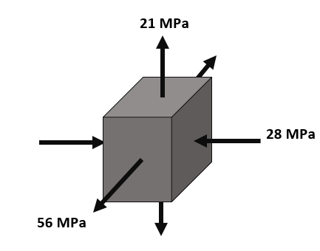

Figure 6 (b)

Figure 6 (a)

1. Determine the elastic strain in the z-direction. [3]
2. Hence calculate the change in the length of the side z of the bar. [2]

**[Total 24]**

**END OF EXAMINATION**

**Data sheet**

|  |  |
| --- | --- |
|  | |
|  | |
|  |  |
|  | |
|  | |
|  | |
|  |  |

|  |  |  |  |  |
| --- | --- | --- | --- | --- |
| **Metal** | **Young’s Modulus (GPa)** | **Poisson’s ratio** | **Yield strength (MPa)** | **Ultimate tensile strength (MPa)** |
| Aluminium | 71.7 | 0.330 | 125 | 294 |
| 1020 steel  [hot rolled] | 207 | 0.292 | 210 | 380 |
| 1020 steel  [cold rolled] | 207 | 0.292 | 390 | 1090 |
| Annealed copper | 119 | 0.326 | 80 | 198 |
| 1040 steel  [forged] | 207 | 0.292 | 365 | 634 |