**;**

#### MANICALAND STATE UNIVERSITY OF APPLIED SCIENCES

**FACULTY OF ENGINEERING, APPLIED SCIENCES AND TECHNOLOGY**

**DEPARTMENTS: METALLURGICAL ENGINEERING/ CHEMICAL AND PROCESSING ENGINEERING**

**MODULE: HYDROMETALLURGY 1**

**CODE: ENGM 225**

**SESSIONAL EXAMINATIONS**

**DECEMBER 2023**

**DURATION: 3 HOURS**

**EXAMINER: MS MT MAJAHA**

## **INSTRUCTIONS**

1. *Answer* ***Question 1*** *in Section A and any* ***three*** *in Section B*
2. *Total marks 100*

***ADDITIONAL MATERIALS***

*Scientific calculator*

**SECTION A: ANSWER ALL QUESTIONS**

**QUESTION 1**

1. State and explain any two methods of leaching [4]
2. Discuss the steps involved in hydrometallurgical processing plants. [15]
3. Differentiate between chemical and reductive non-oxidative leaching processes, describing in detail a dissolution process which makes use of each. [15]
4. Figure 1 shows Eh-pH diagram for a Zinc- Water system. What information about zinc dissolution can you deduce from the diagram? Include equations in your answer. [6]

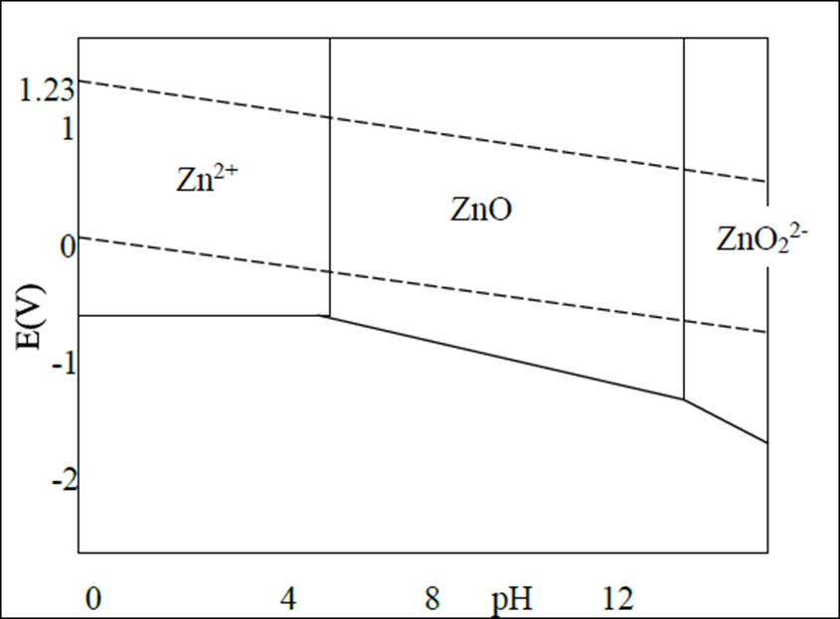

*Figure 1*

**SECTION B: ANSWER ANY THREE QUESTIONS**

**QUESTION 2**

1. Describe the cyanidation process of gold ores. [12]
2. Describe the leaching process of ores by micro-organisms. [8]

**QUESTION 3**

1. As a metallurgical/process engineer, explain in detail factors you would take in consideration when choosing a lixiviant for a leaching process. [4]
2. Explain the four important factors which influence the viability of a leaching process. [4]
3. Discuss steps you would take in developing a leaching process route. [12]

**QUESTION 4**

1. State the characteristics of an ideal extractant used in solvent extraction.[4]
2. Discuss ion exchange process in detail. [8]
3. Distinguish between emulsion liquid membrane systems and supported liquid membrane systems. [8]

**QUESTION 5**

1. Describe in detail the Merril-Crowe process [10]
2. Differentiate between electro-winning and electro-refining operations [6]
3. Calculate the mass of Cu deposited onto an inert lead cathode in an electrolytic extraction where the electrolytic cell is receiving a current of 20 Amps for a duration of 3 hours. (Given Ar of Cu 64) [4] **END OF EXAMINATION**