;

#### MANICALAND STATE UNIVERSITY OF APPLIED SCIENCES

FACULTY OF ENGINEERING,APPLIED SCIENCES AND TECHNOLOGY

**DEPARTMENT: MINING AND MINERAL PROCESSING ENGINEERING**

**MODULE: REFRACTORY MATERIALS**

**CODE: HMME 323**

### SESSIONAL EXAMINATIONS

**DECEMBER 2023**

**DURATION: 3 HOURS**

**EXAMINER: MR J KURIRAI**

## INSTRUCTIONS

1. *Answer* ***All*** *in Section A*
2. *Answer* ***two*** *question in Section B.*
3. *Start a new question on a fresh page*
4. *Total marks 100*

***Additional material(s):***  *Calculator*

**SECTION A**

**QUESTION A1**

1. Refractories are very important to Metallurgical Engineers refining metals and heat treating them at elevated temperatures in the different furnaces. Sufficiently explain with examples why refractories are a necessity in such furnaces. [10]
2. Refractory materials can be classified according to form. Discuss the two classes with examples highlighting the merits and demerits of each class. [12]
3. Refractories may fail resulting in a number of problems to the personnel. Discuss the factors that may contribute to the failure of refractory materials. [8]
4. As the metallurgical Engineer tasked in the designing of the blast furnace. Discuss the aspects which you will consider in selecting the refractory materials for each section of the blast furnace. [12]
5. Explain, with sufficient examples, how energy can be conserved in the furnace and heat losses minimised. [10]
6. Refractories are classified according to composition. Discuss the classes and for each class give at least one refractory material that falls under it. [10]

**SECTION B**

**QUESTION B1**

Give a detailed account of refractoriness, porosity and slag permeability, strength, specific gravity and spalling and show how they determine your refractory performance. [25]

**QUESTION B2**

1. A refractory material consist of graded aggregate that is bonded through a matrix phase. As the Metallurgist elaborate how these two phases contribute to the final properties of your refractory material. [5]
2. There are many compounds which are used in manufacturing refractory materials. Choose five raw materials and, using their properties, show how they suited for their purpose. [20]

**QUESTION B3**

Consider the SiO2-CaO-MgO phase diagram in Fig 1:

Identify the types of ternary invariant points that exist in the system, and write down the reactions that are associated with each. [25]

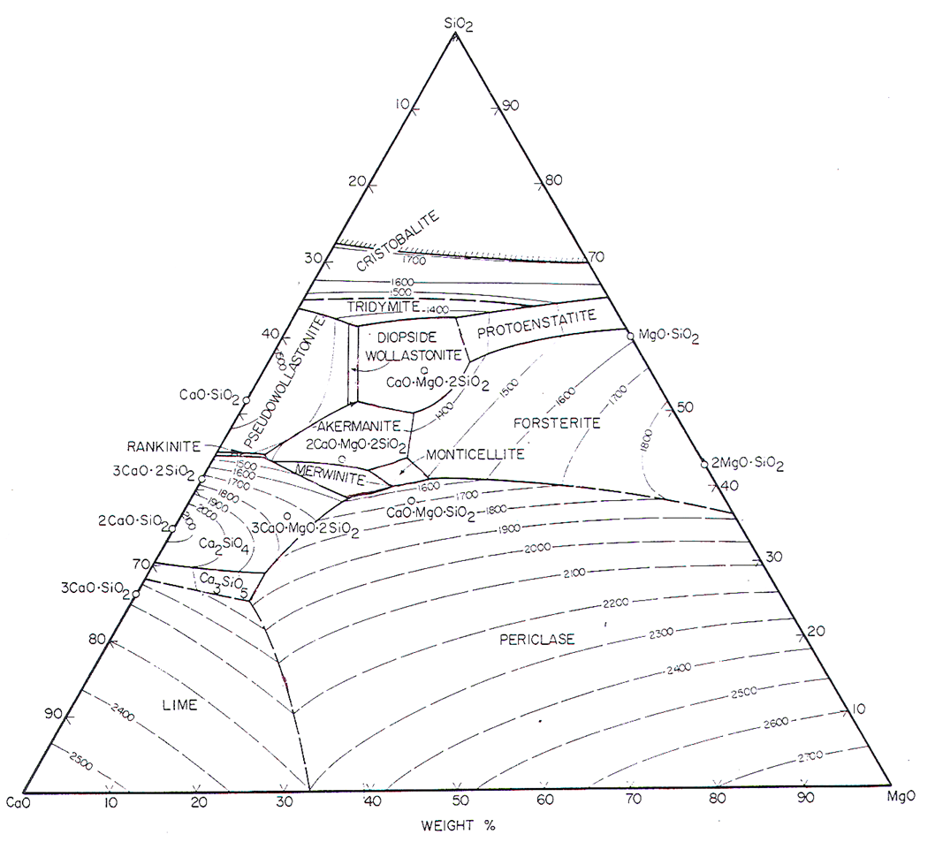

Figure 1

**END OF EXAMINATION**