

#### MANICALAND STATE UNIVERSITY OF APPLIED SCIENCES

FACULTY OF ENGINEERING, APPLIED SCIENCES AND TECHNOLOGY

**DEPARTMENT: MINING AND MINERAL PROCESSING ENGINEERING**

**MODULE: PHYSICAL METALLURGY II**

**CODE: ENGM 321**

### SESSIONAL EXAMINATIONS

**JUNE 2023**

**DURATION: 3 HOURS**

**EXAMINER: ENG M S. MULAKAZUWA**

## INSTRUCTIONS

1. *This paper contains* ***ONE*** *section and* ***FIVE*** *questions*
2. *Answer* ***QUESTION ONE*** *and* ***Any other three questions.***
3. *Each question carries a total of* ***25 marks.***
4. *Start each question on a new page.*

***Additional material(s): Calculator***

**Question One**

The volume free energy change, ∆Gv when liquid metal freezes to the solid state at a temperature T, which is below the equilibrium melting point, Tm, is given by:

∆Gv= ∆Hv, where ∆Hv is the enthalpy of fusion per unit volume.

1. If freezing commences by atoms of the liquid clustering to form solid spherical nuclei, show that the critical radius, r* of such a nucleus is,

r* = $\frac{{2γ}_{SL}T_{m}}{{∆H}_{v}\left(T_{m}−T\right)}$

where $γ_{SL }$ is the free energy change of the solid/liquid interface. $\left[9 marks\right]$

1. Evaluate in terms of the same quantities the critical amount of energy, ∆G*v, necessary to form such a stable nuclei.

$\left[8 marks\right]$

1. State the equation for the free energy change for heterogenous nucleation, defining all the terms in this equation. $\left[8 marks\right]$

**Question Two**

1. Outline the mechanisms involved in solidification of a metal ingot casting and the resulting as-cast structure mentioning in particular the factors which determine the relative proportions of the columnar and equi-axed crystals**. $\left[15 marks\right]$**
2. Describe and explain the phenomena that lead to dendritic solidification in
3. a pure metal
4. a solid solution

Suggest a way of avoiding dendritic solidification in each case. **[10 marks]**

**Question Three**

In the minerals industry in particular, the finer the ground material the greater the liberation of “valuable minerals” will be. Grinding balls are one type of grinding media used to crush or grind such materials in a mill. According to the material to be crushed or ground, appropriate grinding media (alloy steels) can be selected for a particular application due to their specific properties and advantages.

In detail discuss what alloy steels are and their importance with respect to any five alloying elements used in steels that give rise to the desired properties.

$\left[25 marks\right]$

**Question Four**

1. Describe in detail the **two** atomic mechanisms of diffusion. $\left[8 marks\right]$
2. Briefly discuss the **3** factors that affect the rate of diffusion. $\left[3 marks\right]$
3. Two pieces of copper are joined together by melting the ends of the pieces together (welding). If the original pieces are microstructually as shown in the diagram below,

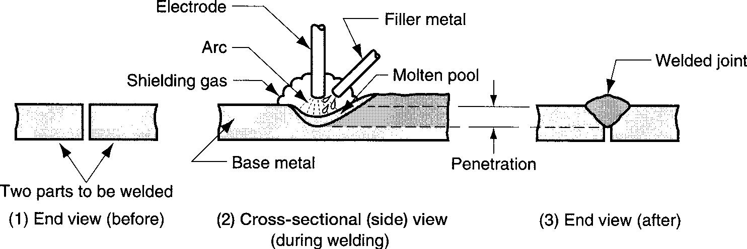

Figure 2: Basics of arc welding: (1) before the weld; (2) during the weld (the base metal is melted and filler metal is added to the molten pool); and (3) the completed weldment.

1. What will the grain structure look like after the weld is done $\left[4 marks\right]$
2. What are the limitations of brazing welding $\left[4 marks\right]$
3. Using a well labelled diagram, describe the principle operation of friction welding $\left[6 marks\right]$

**Question Five**

1. Identify the microstructure shown in **Figure 1**, and discuss how it is formed and its applications. $\left[25 marks\right]$

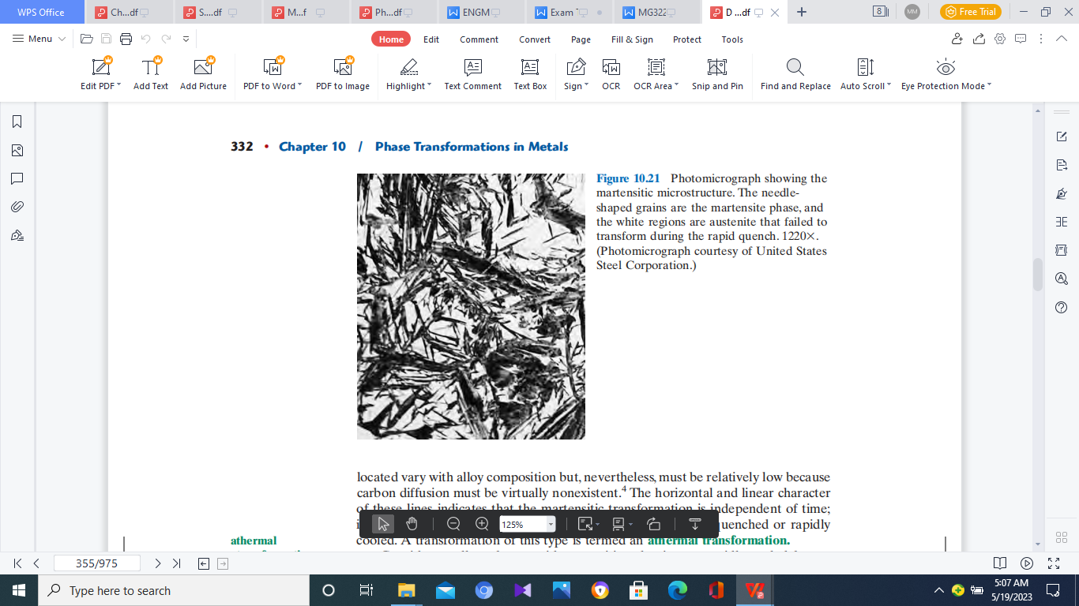

Figure 1: Steel Micrograph

**END OF EXAMINATION PAPER**