;

#### MANICALAND STATE UNIVERSITY OF APPLIED SCIENCES

FACULTY OF ENGINEERING, APPLIED SCIENCES AND TECHNOLOGY

**DEPARTMENT: MINING AND MINERAL PROCESSING ENGINEERING**

**MODULE: PYROMETALLURGY (NON-FERROUS)**

**CODE: ENGM 322**

### SESSIONAL EXAMINATIONS

**JUNE 2023**

**DURATION: 3 HOURS**

**EXAMINER: ENG M S. MULAKAZUWA**

## INSTRUCTIONS

1. *This paper contains* ***ONE*** *section and* ***FIVE*** *questions*
2. *Answer* ***QUESTION ONE*** *and* ***Any other three questions.***
3. *Each question carries a total of* ***25 marks.***
4. *Start each question on a new page.*

***Additional material(s): Calculator***

**Question One**

You are employed as a Process Metallurgist at Mhangura Mines Limited. Explain concisely the fundamentals of non-ferrous pyro-metallurgy for metal extraction of a wet chalcopyrite flotation concentrate from Mhangura to blister copper. In your response correlate the theory of thermodynamics to the stage wise process conversion of the metal from the concentrate to the smelter product justifying the steps you would consider to economically recover the metal. $\left[25 marks\right]$

**Question Two**

(a) Discuss the merits and demerits of submerged arc furnace smelting. **[10 marks]**

(b) In a copper ore, chalcopyrite (CuFeS2) is 34%, pyrite (FeS2) is 30% and SiO2 is 36%

(i) Determine the % Cu and % gangue in the ore $\left[5marks\right]$

(ii) What % Fe in the ore concentrate is to be removed to make 40% matte?

Consider Cu2S

(iii) If only excess S is eliminated in the ore concentrate, what is the composition of the resulting matte? $\left[5 marks\right]$

AWCu= 64, AWFe= 56, AWS= 32

**Question Three**

(a) Discuss the factors you would consider in the choice of a refractory lining for a specific non-ferrous metallurgy smelting operation? $\left[10 marks\right]$

(b) Explain with justification how you can process lumpy chromite ore mined from the Zimbabwean South Dyke to produce a High Carbon Ferrochrome alloy?

$\left[15 marks\right]$

**Question Four**

1. Smelting is a unit process at which heat is applied to a mixture of ore concentrate, flux and fuel (if necessary) above the melting point to separate the gangue mineral from ore in the liquid state. There are two main types of smelting. Discuss the main differences between ***matte smelting*** and ***reduction smelting. $\left[5 marks\right]$***
2. Copper making was revolutionized in the 1970s in Australia by the use of top-lancing technology for injecting coal into copper slags to improve reduction kinetics. Discuss the operation and functions of the Ausmelt or Isasmelt technology guided by the following:
3. Raw materials used $\left[5 marks\right]$
4. Operating mechanism applied $\left[10 marks\right]$
5. Types of fuel applied $\left[5 marks\right]$

**Question Five**

1. Give an account of smelting of nickel based pentlandite ores prior to electrolytic refining. $\left[12 marks\right]$
2. Copper ore is smelted in a reverberatory furnace together with a copper concentrate. The fluxes are pure CaCO3 and iron ore

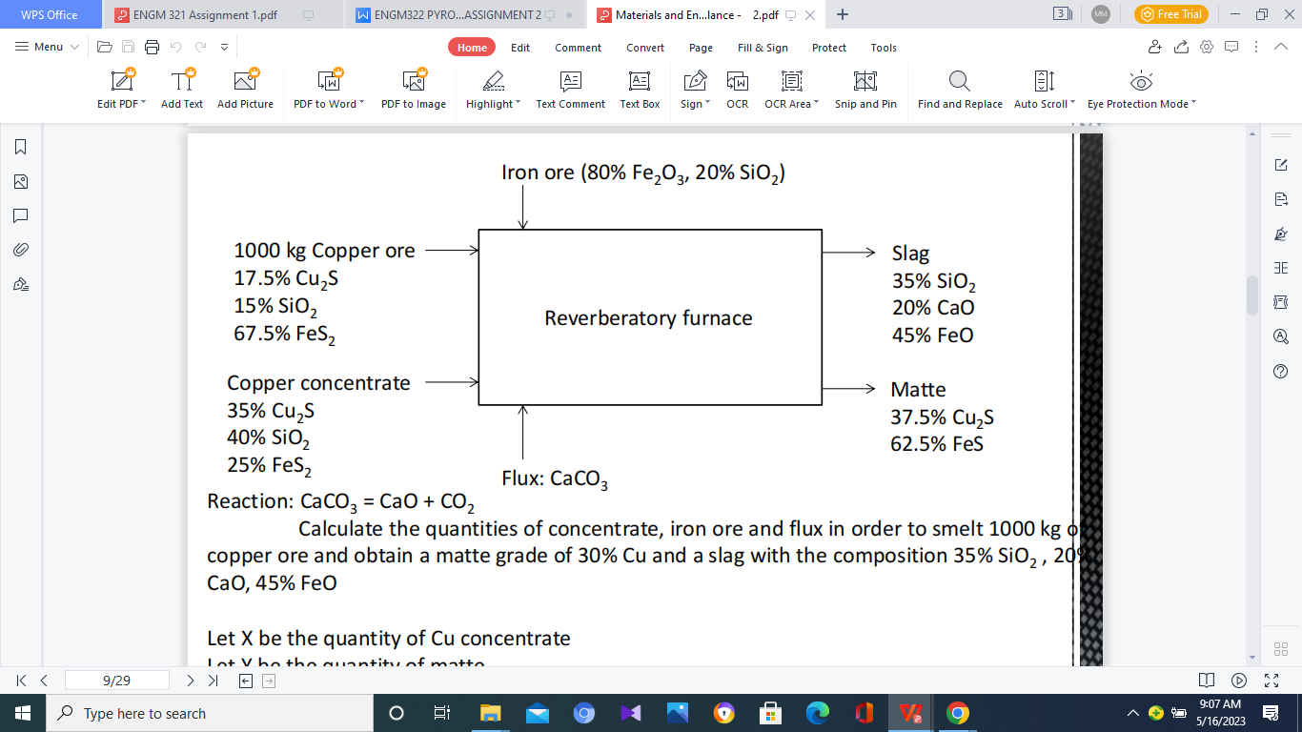

Calculate the quantities of concentrate, iron ore and flux in order to smelt 1000 kg of copper ore and obtain a matte grade of 30% Cu and a slag with the composition 35% SiO2, 20% CaO, 45% FeO

**END OF EXAMINATION**