;

MANICALAND STATE UNIVERSITY OF APPLIED SCIENCES

FACULTY OF ENGINEERING, APPLIED SCIENCES AND TECHNOLOGY

**DEPARTMENT: MINING AND MINERAL PROCESSING ENGINEERING**

**MODULE: METALLURGICAL THERMODYNAMICS**

**CODE: ENGM 223**

### SESSIONAL EXAMINATIONS

**JUNE 2023**

**DURATION: 3 HOURS**

**EXAMINER: ENG M S. MULAKAZUWA**

INSTRUCTIONS

1. *This paper contains* ***ONE*** *section and* ***FIVE*** *questions*
2. *Answer any* ***FOUR*** *questions.*
3. *Each question carries a total of* ***25 marks.***
4. *Start each question on a new page.*

***Additional material(s): Calculator***

**Question One**

1. In thermodynamics, the term “***system***” means a portion of the physical universe, large or small, enclosed by a real or an imaginary boundary and thus separated from the rest of the universe, which constitutes the “surroundings”. The system can be either homogeneous or heterogeneous.

**Define** and **explain** briefly the three types of metallurgical systems. $\left[9marks\right]$

1. Explain why a **Rankine Cycle** is a critical metallurgical example of a **closed system.** Marks are awarded for the ***detailed explanation*** of each stage in the cycle. $\left[16 marks\right]$

**Question Two**

1. Discuss the differences between the entropy change for a reversible process and an irreversible process. $\left[4 marks\right]$
2. Define and explain the criterion of spontaneity based on free Energy. $\left[5 marks\right]$
3. Show that for a substance in its standard state, if there is phase transformation such as melting, vaporization, e.t.c., the entropies $S_{T_{2}}, S_{T_{1}}$ of the system at temperatures T’ between T2 and T1 are given by

$$S_{T_{2}}^{°}=S_{T_{1}}^{°}+\int_{T_{1}}^{T^{'}}{\frac{C_{p}^{'}}{T}dT}+\frac{H_{t}}{T^{'}}+\int_{T_{1}}^{T_{2}}{\frac{C_{p}^{''}}{T}dT}$$

where $C_{p}^{'}$ and $C_{p}^{''}$ are the heat capacities of the substance before and after the transformation, respectively, and Δ $H_{t}$. is the enthalpy change of the transformation. $\left[16 marks\right]$

**Question Three**

1. In the basic open-hearth process, the reaction of manganese in the bath with iron oxide (FeO) in the slag attains a condition very closely approximating to true equilibrium. The steel contains 0.065 atom % manganese and the slag analysis (by weight) is

FeO - 76.94% , Fe 03 - 4.15% , MnO - 13.86% ,

MgO - 3.74% , SiO - 1.06% , and CaO - 0.25%.

Given that the expression of the reaction which occurs is

$${(FeO)}_{slag}+{\left[Mn\right]}_{metal}={(MnO)}_{slag}+{\left[Fe\right]}_{metal}$$

Calculate the value of the **equilibrium constant** and **standard free energy** change for the above reaction at 1655 $°C$ (1928 K), assuming that the slag and Fe-Mn system behave ideally at that temperature. Neglect the effect of other metalloids present in the steel.

Given: Molecular weights of FeO: 71.85, Fe203: 159.85,

MnO: 70.94, MgO: 40.32, Si02 : 60.09 and CaO: 56.08.

$\left[25 marks\right]$

**Question Four**

For the reaction $A+B=C$, the following data were determined

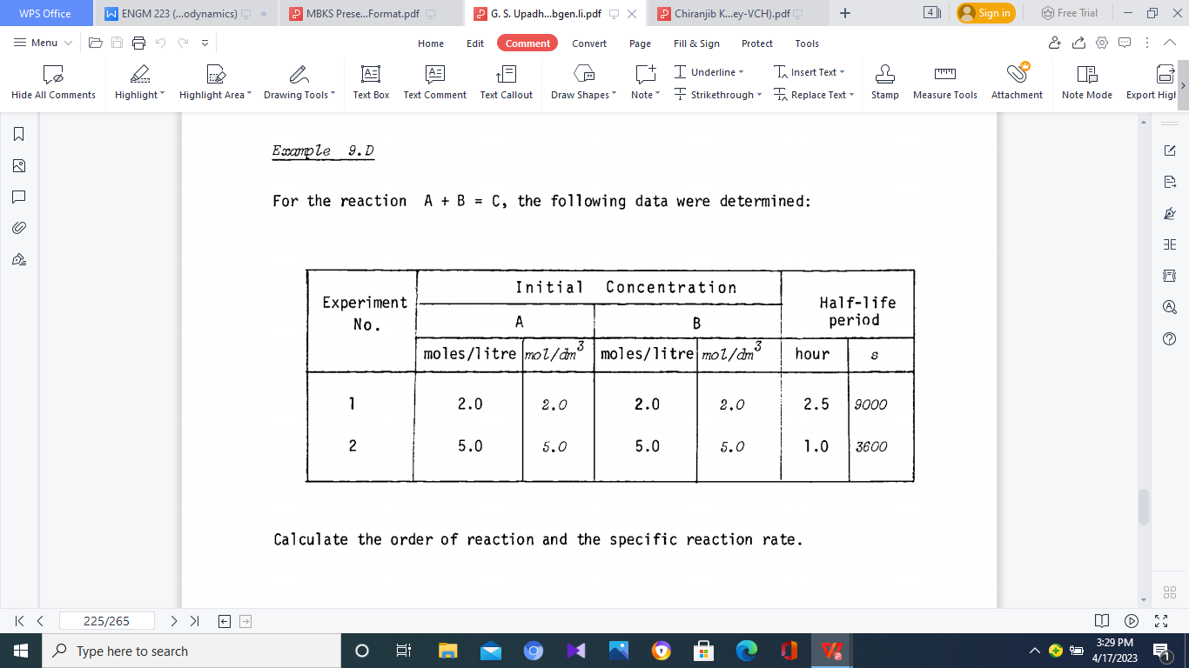

1. Calculate the order of reaction and the specific reaction rate. $\left[15 marks\right]$
2. Describe in detail (including equations) the two important theories of reaction kinetics - the collision theory, and absolute reaction rate theory. $\left[10 marks\right]$

**Question Five**

1. By combining the 1st and 2nd laws of thermodynamics for a system doing work against pressure at constant temperature. Show that if gas is not ideal

$dG=R∙T∙d Inf (i)$

where the function ‘f’ is called fugacity of the gas. $\left[7 marks\right]$

1. The behaviour of most metallurgically important solutions could be described by certain simple laws. Describe and explain briefly the fundamental laws that govern the behaviour of metallurgical solutions. $\left[8 marks\right]$
2. The above important relationship now allows evaluation of the thermodynamic driving force of a redox reaction in terms of a measurable cell emf. Moreover, it is possible to utilize the relationship between the standard state potential and the standard state free energy to arrive at an expression for the equilibrium constant of a redox reaction in terms of the emf.

If the conditions of constant temperature and pressure are imposed, the free energy expression will then become

(dG)T,P = µ1 dn1 + µ2 dn2 + µ2 dn2 … (ii)

If one considers the reaction in the galvanic cell to be

na A + nb B = nc C + nd D (iii)

Using the data given in equation (ii) and equation (iii) Derive the Nernst equation,

$$∆E={∆E}^{0}+\frac{RT}{nF}ln\frac{{\left(a_{C}\right)}^{n_{c}}{\left(a_{D}\right)}^{n_{d}}}{{\left(a_{A}\right)}^{n_{a}}{\left(a_{B}\right)}^{n_{b}}}$$

$\left[10marks\right]$

**END OF EXAMINATION**