;

#### MANICALAND STATE UNIVERSITY OF APPLIED SCIENCES

FACULTY OF ENGINEERING, APPLIED SCIENCES AND TECHNOLOGY

**DEPARTMENT: MINING AND MINERAL PROCESSING ENGINEERING**

**MODULE: MINE VENTILATION**

**CODE: HMIE 511**

### SESSIONAL EXAMINATIONS

**JUNE 2023**

**DURATION: 3 HOURS**

**EXAMINER: MR MUTIZHE**

## INSTRUCTIONS

1. *Answer* ***all*** *questions in Section A and any three(3) questions from section B*
2. *Each question carries 20 marks*
3. *The paper consist of 6 printed pages*
4. *Total marks 100*

***Additional material(s):*** *pen, pencil*

**Section A**

**Question 1**

1. Arrange six common gases found in underground operation in order of their maximum permissible quantity solubility and specific gravity **[8]**
2. An airway splits into three ventilation district A, B and C. The ventilation district airway have the following attributes;  
    Airway 1 (A) Airway 2(B) Airway 3(C)  
   Width 5 m 5 m 4  
   Height 4 m 3 m 4  
   Length 200 m 300 m 150m  
   K factor 0,01 0,08 0.04  
   QTOT = 70 m3/s = Q1 + Q2 + Q3  
   ω = 1,0 kg/m3  
   Calculate the pressure drop in ventilation district A, B and C and quantities Q1 , Q2, Q3 respectively.**[12]**

|  |
| --- |
| **Question 2**   1. A fan passes an airflow of 300m3/s at the inlet, and develops a pressure of 2.5kPa. The barometric pressure at the inlet is 97kPa. The motor consumes an electric power of 1100kW. Assuming a combined motor/transmission efficiency of 95% determine the isentropic efficiency of the impeller and also of the total unit. **[8]** 2. The Fig 2 below shows a simplified ventilation network served by a downcast and an upcast shaft, each passing 100m3/s. The resistance of each subsurface branch is shown. A fan boosts the airflow in the central branch to 40m3/s. Determine the distribution of airflow and the total pressure Pb developed by the booster fan. **[12]** 3. Fig 2     **Section B** |

**Question 3**

1. Briefly discuss how you design the ventilation system for setup in Fig 2. **[10]**

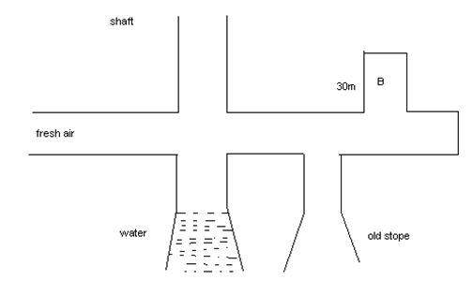

b.The diagram below shows two decline shafts which are being sunk at the same time (simultaneously). The declines are parallel dipping at 80. Pillars of 4.5m x7m are left behind as support, can you ventilate these two declines using force exhaust overlap system? 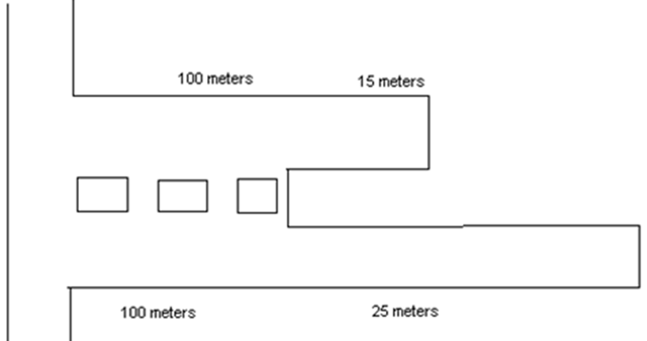 **[10]**

**Question 4**

1. Briefly compare centrifugal fans and axial fans **[5]**
2. Development ends are one of the active areas that require adequate ventilation at all time. It is there important you discuss your knowledge the two systems that can be used to ventilate any development end, including their main advantages and disadvantages. **[15]**

**Question 5**

You are in charge of developing a ventilation system for an underground mine, which is at its design stage. However, there are three alternatives for supply of air to 3000m long cross-cuts which are to circulate about 400m3s-1 of air and an economic alternative has to be selected from the following options;

**Option 1**

* Cross-cut 4m x 3m
* K = 0.0098n2m-4
* Cost (ventilation fan) = US$ 500/m

**Option 2**

* Cross-cut 4 m x 3.3m
* K = 0.0098n2m-4
* Cost (ventilation fan) = US$ 600/m

**Option 3**

* Cross-cut 2.8 m x 2.5m
* K = 0.0098n2m-4
* Cost (ventilation fan) = US$ 5400/m

Assumptions:

* The cost of power 14c/kwh
* Fan efficiency 80%
* Motor efficiency 90%

Which one is the economic option?  **[20]**

**Question 6**

a. With the use of diagrams explain the effect of connecting two similar fans in

i. Series

ii. Parallel **[10]**

b. A fan is running at a speed of 10 revs per second and the density of air is 1.2 kg/m3. The fan will deliver 115m3/s at 13.7 mbar using 225KW and an efficiency of 70.2%. If the fan runs at 13.3 rps and handling air density of 1.04kg/m3 what will be the new:

1. Quantity
2. Pressure
3. power **[10]**

**Question 7**

1. Briefly discuss mine ventilation economics stressing the needs for improving efficiency of ventilation plant operations. **[10]**
2. Briefly discuss the advantages and disadvantages of using negative and positive pressure system in underground workings  **[10]**

**END OF QUESTION PAPER**