**;**

#### MANICALAND STATE UNIVERSITY OF APPLIED SCIENCES

**FACULTY OF ENGINEERING, APPLIED SCIENCES AND TECHNOLOGY**

**DEPARTMENT: METALLURGICAL ENGINEERING**

**MODULE: HEAT TRANSFER AND MASS TRANSFER**

**CODE: ENGM 211**

**SESSIONAL EXAMINATIONS**

**JUNE 2023**

**DURATION: 3 HOURS**

**EXAMINER: MS MT MAJAHA**

## **INSTRUCTIONS**

1. *Answer any* ***four questions***
2. *Total marks 100*

***ADDITIONAL MATERIALS***

*Scientific calculator*

**QUESTION 1**

1. State and explain the three modes of heat transfer [12]
2. What are the differences between heat transfer and thermodynamics? [4]
3. A carbon steel plate (thermal conductivity = 45 W/m°C) 600 mm x 900mm x 25mm is maintained at 310°C. Air at 15°C blows over the hot plate. If convective heat transfer coefficient is 22 W/m2°C and 250 W is lost from the surface by radiation, calculate the inside plate temperature. [9]

**QUESTION 2**

1. A furnace wall consists of 20 cm of fire brick (k = 1 W/m.K), 15cm of insulating brick (k = 0.12 W/m.K). The inner wall of the firebrick is exposed to furnace gas at 1200K whilst are at 310K is adjacent to the outside wall of the red brick. The inside and outside convective heat transfer coefficients are 95 and 20 W/m2K respectively. Determine
   1. The heat loss per square meter of wall
   2. The temperature of the outside wall surface [10]
2. Calculate the rate of cooling of an aluminium plate (1.5 m by 1.5 m) at 580K when it is suspended horizontally in stagnant air at 300K. The heat transfer coefficient is estimated using the following correlation

*Nu L = (Gr L)1/3Pr1/3*

Where *GrL = (L3p2ɡβΔT)/µ2*

The properties of air evaluated at the film temperature of 440K are

*p =* 0.8021kg/m3; *Cp =* 1.0197 x 103 J/kgK; µ = 2.4453 X 10-5 Pas; *k =* 3.6427 x 10-2 W/mK; β =2.2681 x 10-3 K-1 . [15]

**QUESTION 3**

1. A standard cast iron pipe (inner diameter = 50 mm and outer diameter = 55 mm) is insulated with magnesium insulation (k = 0.02 W/m°C). Temperature at the interphase between the pipe and insulation is 300°C. The allowable heat loss through the pipe is 600 W/m length of pipe and for safety, the temperature of the outside surface must not exceed 100°C.

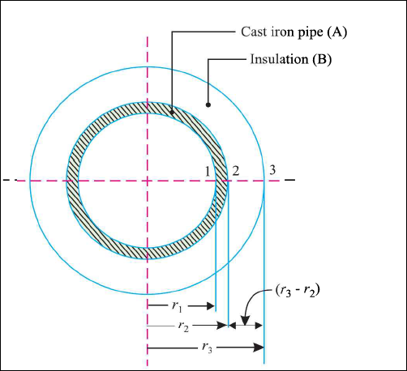

Determine;

1. Minimum thickness of insulation required
2. The temperature of inside surface of pipe given that its thermal conductivity is 20W/m°C.

[15]

b) A spherical shaped vessel of 1.4 m diameter is 90mm thick. Find the rate of heat leakage, if the temperature difference of the inner and outer surfaces is 220°C. Thermal conductivity of the material of the sphere is 0.083 W/m°C.[5]

1. A wire 1.5 mm in diameter and 150mm long is submerged in water at atmospheric pressure. An electric current is passed through the wire and is increased until the water boils at 100°C. Under the condition if convective heat transfer coefficient is 4500 W/m2°C, find how much electric power must be supplied to the wire to maintain the wire surface at 120°C? [5]

**QUESTION 4**

1. Discuss on the modes of mass transfer [10]
2. State Fick’s law of mass diffusion [5]
3. Hydrogen gas at 25 °C and 2.5 atmosphere flows through a rubber tubing of 12mm inside radius and 24mm outside radius. The binary diffusion coefficient of hydrogen is 2.1 x 10-8 m2/s and the solubility of hydrogen is 0.055 m3 of hydrogen per m3 of rubber at 1 atmosphere. If the gas constant for hydrogen is 4160 J/kgK and the concentration of hydrogen at the outer surface of tubing is negligible, calculate the diffusion flux rate of hydrogen per meter length of rubber tubing. [10]

**QUESTION 5**

1. State the four laws of thermodynamics [4]
2. Define the following terms as used in thermodynamics
3. Adiabatic system [2]
4. Process [1]
5. Work [2]
6. Differentiate between intensive and extensive properties of a system giving two examples of each. [6]
7. A surface having an area of 1.5 m2 and maintained at 300 °C exchanges heat by radiation with another surface at 40 °C. The value of factor due to geometric location and emissivity is 0.52. Determine;
   1. Heat lost by radiation
   2. The value of thermal resistance
   3. The value of equivalent convection coefficient [10]

**END OF EXAMINATION**