;

#### MANICALAND STATE UNIVERSITY OF APPLIED SCIENCES

FACULTY OF ENGINEERING, APPLIED SCIENCES AND TECHNOLOGY

**DEPARTMENT: MINING AND MINERAL PROCESSING ENGINEERING**

**MODULE: PRINCIPLES OF ELECTRICAL ENGINNERING / ELECTRICAL MACHINES**

**CODE: ENGT221/HMIE221**

### SESSIONAL EXAMINATIONS

**DECEMBER 2023**

**DURATION: 3 HOURS**

**EXAMINER: E CHIPFUPI**

## INSTRUCTIONS

1. *Answer* ***all*** *Questions in Section A and any three Questions in Section B*
2. *Total marks:100 $$μ_{0}=4π×\frac{{10}^{-7}H}{m} \\ ε_{0}=8.85 × {10}^{-12}C^{2}N/m^{2}$$*

**Section A:** Answer ***all*** Questions **QUESTION 1**

1. Distinguish between synchronous and asynchronous machines. Give an example of each. **[4]**
2. With the aid of a diagram, describe the external characteristics of a separately excited dc generator. **[15]**
3. Describe the effect of armature reaction on an electrical machine. **[5]**
4. With the aid of diagrams describe ***any two*** methods that can be used to start motors. Explain the advantages and disadvantages of each method.  **[16]**

**Section B :** Answer **any three** Questions

**QUESTION 2**

1. A 12 kW, 100 V, 1000 rpm dc shunt generator has armature resistance Ra = 0.1 Ω, shunt field winding resistance Rfw = 80 Ω, and Nf = 1200 turns per pole. The rated field current is 1 ampere. The magnetization characteristic at 1000 rpm is shown in Figure1.1. The machine is operated as a separately excited dc generator at 1000 rpm with rated field current **[12]**

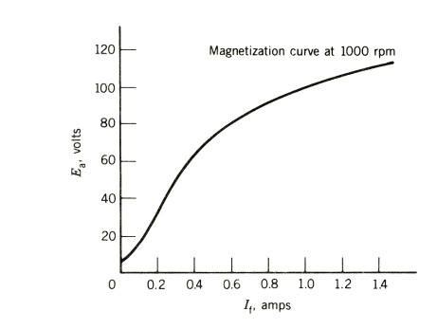

**b.** A 230-V dc shunt motor has an armature-circuit resistance of 0.23 Ω. When  
operating from a 230-V supply and driving a constant-torque load, the motor  
is observed to be drawing an armature current of 60 A. An external resistance  
of 1.0 Ω is now inserted in series with the armature while the shunt field  
current is unchanged. Neglecting the effects of rotational losses and armature  
reaction, calculate  
a. the resultant armature current and  
b. the fractional speed change of the motor. **[8]**

**QUESTION 3**

1. Describe how torque can be controlled in DC machines. **[5]**

1. Describe how torque can be controlled in synchronous motors. **[5]**
2. The generation of electricity from hydrocarbons is associated with pollution, environmental degradation, etc. briefly describe how power can be generated from any **three** clean sources of power. **[10]**

**QUESTION 4**

Measurements on a small permanent-magnet dc motor indicate that it has an  
armature resistance of 4.6 $Ω$. With an applied armature voltage of 5 V, the  
motor is observed to achieve a no-load speed of 11,210 r/min while drawing  
an armature current of 12.5 mA.  
a. Calculate the motor torque constant Km in V/(rad/sec). **[6]**  
b. Calculate the no-load rotational losses in mW. **[3]**

Assume the motor to be operating from an applied armature voltage of  
5V.  
c. Find the stall current and torque of the motor. **[5]**  
d. At what speeds will the motor achieve an output power of 1 W? Estimate  
the motor efficiency under these operating conditions. Assume that the  
rotational loss varies as the cube of the speed. **[6]**

**QUESTION 5**

1. A Three 1φ, 50 kVA, 2300=230 V, 60 Hz transformers are connected to form a 3φ, 4000/230 V transformer bank. The equivalent impedance of each transformer referred to low voltage is 0:012 + j0.016 Ω. The 3φ transformer supplies a 3φ, 120 kVA, 230 V, 0:85 PF (lag) load.(a) Draw a schematic diagram showing the transformer connection. **[5]**  
   (b) Determine the transformer winding currents. **[5]**  
   (c) Determine the primary voltage (line-to-line) required. **[7]**  
   (d) Determine the voltage regulation. **[3]**

**END OF PAPER**