MANICALAND STATE UNIVERSITY

OF

APPLIED SCIENCES

FACULTY OF ENGINEERING

Mining and Mineral Processing Engineering Department
PRINCIPLES OF MATERIALS CORROSION
CODE: HMIE 514

SESSIONAL EXAMINATIONS
MAY 2019

DURATION: 3 HOURS

EXAMINER: MISS KZN CHIWANGA

INSTRUCTIONS
- Answer all questions
- Each question carries 25 marks
- Total marks 100
- Requirements: -Scientific calculator, graph paper
Constants: R= 8.314 J/Kmol,
F = 96500 C/mol,

Question 1
- List seven factors that affect the rate of corrosion or deterioration of protective coatings applied to metals. [7]
- Why is the combination of hydrogen embrittlement corrosion and oscillating stress a serious problem in a metal component? Suggest two ways of assessing the severity of hydrogen embrittlement corrosion. [12]
- Explain how the addition of anodic inhibitor can aggravate a corrosion problem. Name any three examples of anodic inhibitors. [6]

Question 2
              - What precipitates are formed when weld decay occurs in an unstabilised stainless steel? Where are the precipitates formed? [4]
              - Explain the mechanism of weld decay. [6]
              - What elements are added to stainless steels to reduce weld decay? [2]
              - State two other measures which may be taken to alleviate the problem. [3]
              - The following couples are immersed in fresh water:
Fe/Cd Fe/Ti Fe/Zn Fe/Cu
- In which one of the four will the iron corrode the fastest?
- Which combination offers the best protection to the iron? [4]
(Ti²⁺ + 2e Ti -1.63 V)
(Cd²⁺ + 2e Cd -0.403 V)
- A voltaic cell is set up at 25 degrees Celsius with the half cells:
Al³⁺ (0.00050M) |Al and Ni²⁺ (0.25M) |Ni.
Write an equation for the reaction that occurs when the cell generates an electric current, and determine the cell potential. [6]
Question 3
Make use of Fig. 1 to answer the questions that follow.
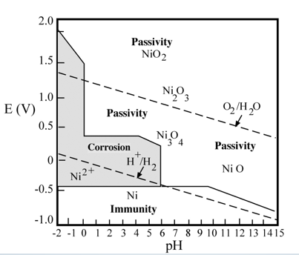
Fig. 1.
- Explain how inspection of the chart suggests three possible methods for controlling the corrosion of nickel in water. [3]
- What factors, if any, might make these suggestions impractical? [3]
- What other factors limit the application of E/pH diagrams to real situations? [4]
- Briefly define each one of the following:
                - Corrosion
                - Passivity
                - Immunity
                - Standard electrochemical potential
                - Exchange current density [10]
- A Ni/Ni²⁺ concentration cell is constructed in which both electrodes are pure nickel. The Ni²⁺concentration for one cell half is 1.0 M and 10⁻² M for the other half. Is there any voltage generated between the two halve cells? If so, what is its magnitude and which electrode will be oxidized? If there is no voltage produced, explain why. [5]
Question 4
              - A voltaic cell is set up with copper and hydrogen half cells. Standard conditions are employed in the copper half-cell, Cu²⁺(aq,1.00M) | Cu_{(s)}.The hydrogen gas pressure is 1.00 bar, and [H⁺_{(aq)}] in the hydrogen half-cell is the unknown. A value of 0.490V is recorded for E cell at 298 K. Determine the pH of the solution. [7]
              - A piece of corroded steel plate was found in a submerged ocean vessel. It was estimated that the original area of the plate was 62.5 cm² and approximately 2.8 kg had corroded during the submersion. Assuming a corrosion penetration rate of 5.1 mm/yr for this alloy in seawater, estimate the time of submersion in years. The density of steel is 7.9 g/cm³ [6]
              - Lead experiences corrosion in an acid solution according to the reaction
Pb + 2H⁺ Pb²⁺ + H₂
The rates of both oxidation and reduction half-reactions are controlled by activation polarization.
- Compute the rate of oxidation of Pb (in mol/cm².s) using activation polarization data shown in Table 1. [8]
- Compute the value of the corrosion potential. [4]
Table 1: Activation polarization data
For Lead | For Hydrogen
V_{(Pb/Pb}²⁺₎ = -0.126 V | V_{(H}⁺/_{H2)} = 0 V
ⅈ₀ = 2 x 10⁻⁹ A/cm² | ⅈ₀ = 1.0 x 10⁻⁸ A/cm²
β= +0.12 | β= -0.10
END OF EXAM

