MANICALAND STATE UNIVERSITY

OF

APPLIED SCIENCES

FACULTY OF ENGINEERING

MINING AND MINERAL PROCESSING ENGINEERING DEPARTMENT

MINE VENTILATION
CODE: HMIE 511

SESSIONAL EXAMINATIONS
MAY 2019

DURATION: 3 HOURS

EXAMINER: B. MUTIZHE

INSTRUCTIONS
- Answer all questions in Section A
- Answer any three questions from section B
- Each question carries 20 marks
- Total marks 100

Section A
Question 1
You are in charge of developing a ventilation system for an underground mine, which is at its design stage. However, there are three alternatives for supply of air to 3000 m long cross-cuts which are to circulate about 400 m³s⁻¹ of air and an economic alternative has to be selected from the following options;
Option 1
- Cross-cut 4 m x 3 m
- K = 0.0098 n²m⁻⁴
- Cost (ventilation fan) = US$ 500/m
Option 2
- Cross-cut 4 m x 3.3 m
- K = 0.0098 n²m⁻⁴
- Cost (ventilation fan) = US$ 600/m
Option 3
- Cross-cut 2.8 m x 2.5 m
- K = 0.0098 n²m⁻⁴
- Cost (ventilation fan) = US$ 5400/m
Assumptions:
- The cost of power 14 c/kwh
- Fan efficiency 80%
- Motor efficiency 90%
- Safe Rate of Interest 4%
- Present value factor 9.39%
Which one is the economic option? [20]

Question 2
- Arrange six common gases found in underground operation in order of their increasing solubility, maximum permissible quantity and specific gravity. [7]
- Group the gases into toxic and poisonous gases and arrange them in their increasing order toxic and poisonous. [3]
- Briefly explain the difference between centrifugal fans and axial fans. [3]
- What is a system resistance curve? Discuss how change in air density and fan speed affects the system curve. [7]
Section B
Question 3
- Fig. 1 shows two decline shafts which are being sunk at the same time (simultaneously). The declines are parallel dipping at 10⁰. Pillars of 3 m x 5 m are left behind as support. Can you ventilate these two declines using force exhaust overlap system? [10]
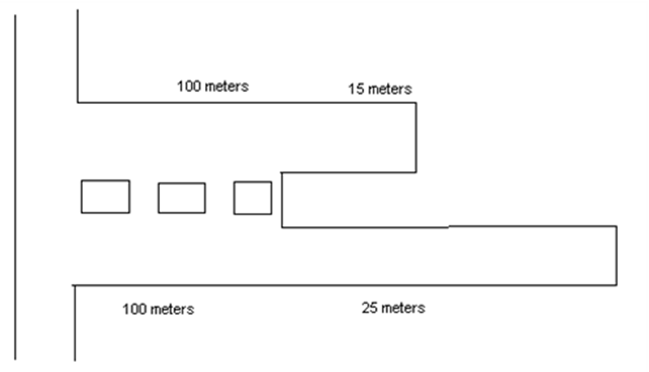
Fig. 1

b)
- Briefly describe methods used to measure the following ventilation parameters in underground working.
- Velocity
- Pressure
- Dust
[10]
Question 4
- Define Natural Ventilation and give two factor lead to flow of air due to Natural Ventilation. [3]
- Consider two shafts having an equal diameter of 7 m and sunk to a depth of 500 m. The two shafts are connected at the bottom by a level of 4 m x 3 m in cross section and 1200 m long. Calculate the average velocity of flow in the level due to natural ventilation if the average barometric pressure in the shaft is 110.27 Kpa.
Given data:
Temperature in D/C shaft top 287K
Temperature in D/C shaft bottom 293K
Temperature in U/C shaft top 300K
Temperature in U/C shaft bottom 300.5K
The coefficient K for the shafts is 0.005 NS²m⁻⁴ and the levels 0.012 NS²m⁻⁴. Neglect shock losses. [17]
Question 5
- With the aid of diagrams explain the effect of connecting two similar fans in
  - Series
  - ii. Parallel [6]
- Briefly explain air recirculation. [4]
- Design a ventilation system that is used in ventilating the development end shown in Fig 2. What are the advantages and disadvantages of each of the systems? Illustrate your answer using diagrams. [10]

40m

Drive

Fig. 2
Question 6
- An airway splits into ventilation district A, B and C. The ventilation district airway have the following attributes;
Airway (A) Airway (B) Airway (C)
Width 6 m 6 m 8
Height 7 m 3 m 9
Length 200 m 300 m 150m
K factor 0,01 0,08 0.04
Q_{Total} = 80 m³/s = Q_{A} + Q_{B} + Q_{C}
ω = 1,3 kg/m³
Calculate the pressure drop in ventilation district A, B and C and quantities Q_{A} , Q_{B}, Q_{C} respectively. [13]
- Design an experiment to measure the fan operating point in underground working. [7]

END OF QUESTION PAPER

